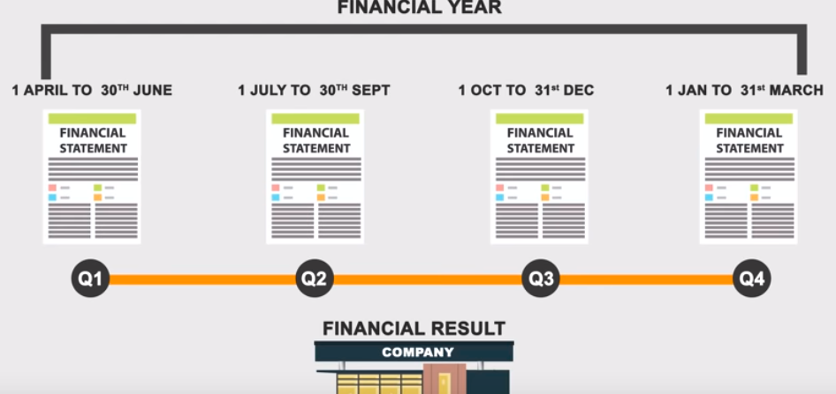

A company declares its financial statement every quarter. There are 4 quarters.Once financial year is over,company creates annual report.

We can find annual report in moneycontrol/screener/zerodha or sharekhan site/company’s website

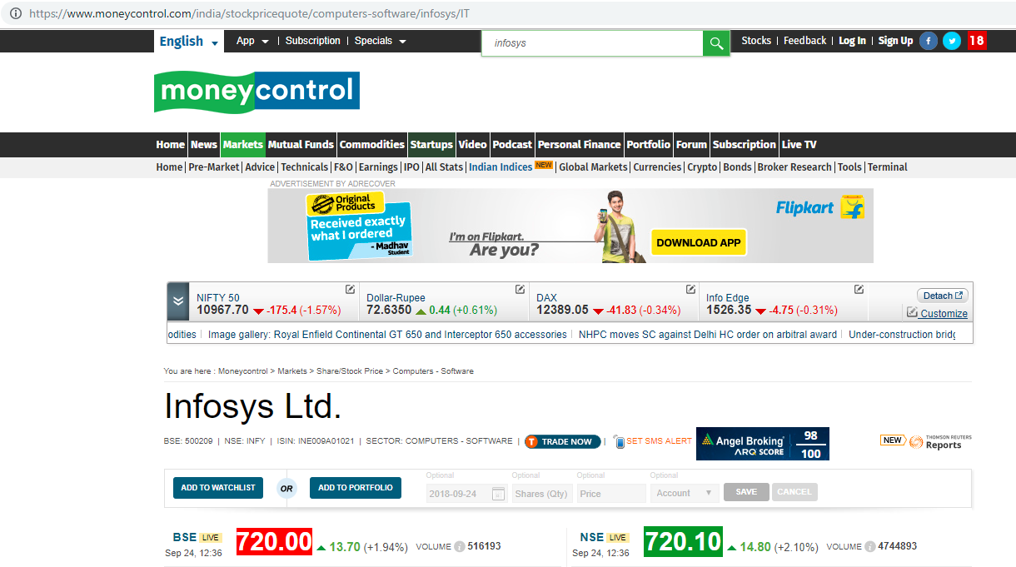

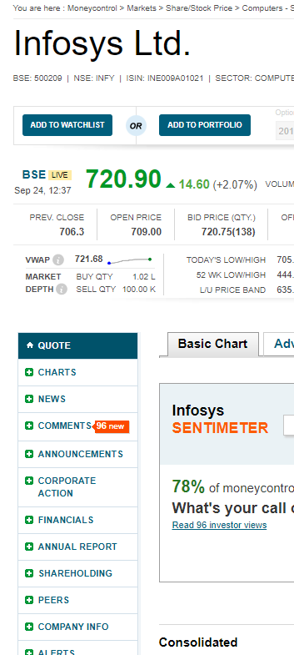

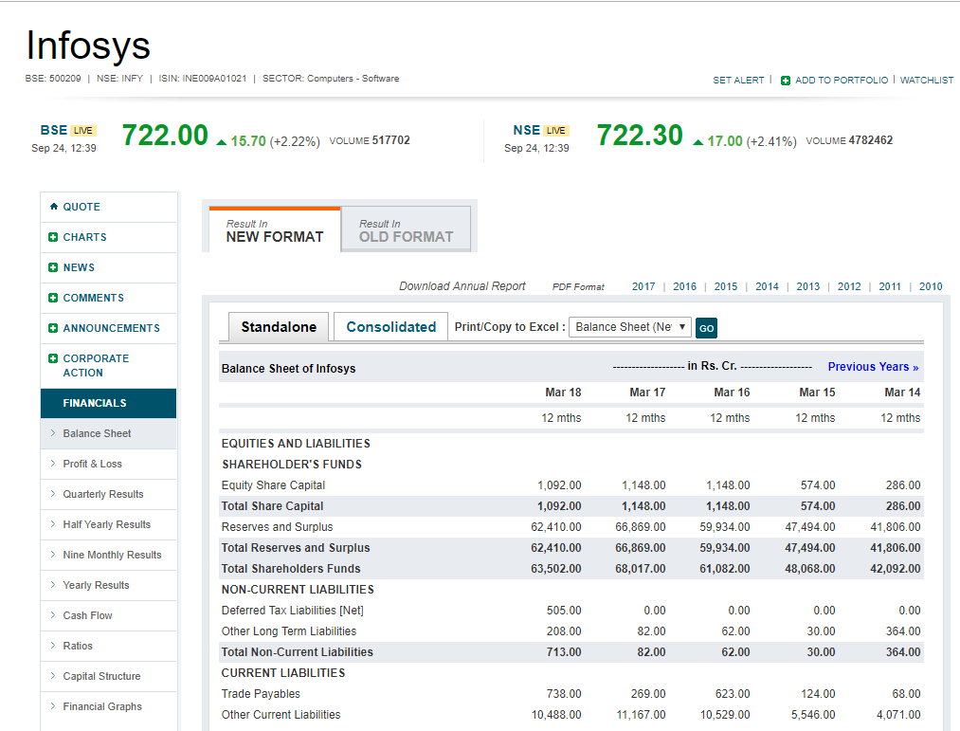

Above we can see the data can be used to put in excel for data analytics/data science

Annual report pdf download link, annual report is what given by company and balance sheet/financial ratio/profit loss/cash flow all this details are present in annual report. This is very big document . Also this document contains future plans/CEO comments. Detail analysis need to read annual report.

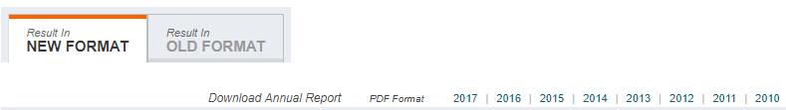

AR contains the auditor’s certificates (signed, dated, and sealed) certifying the sanctity of the financial data included in the annual report.

Potential investors and the present shareholders are the primary audience for the annual report. For an investor, the annual report must be the default option to seek information about a company.

 I have taken the **Annual Report of Amara Raja Batteries Limited, belonging to Financial Year 2013-2014**.

Amara Raja Batteries Limited manufactures automobile and industrial batteries.

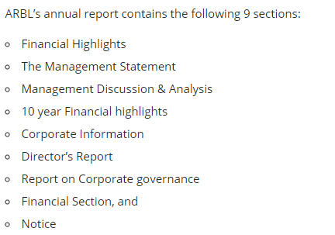

**Financial Highlights** contains the bird’s eye view on how the financials of the company looks for the year gone by

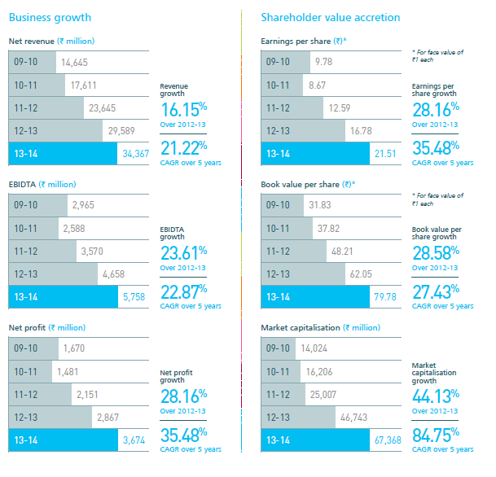

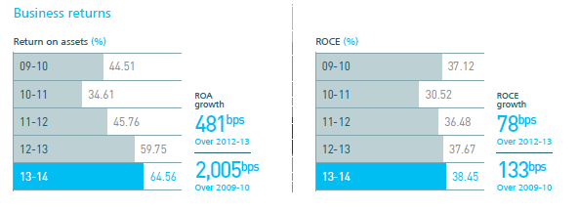

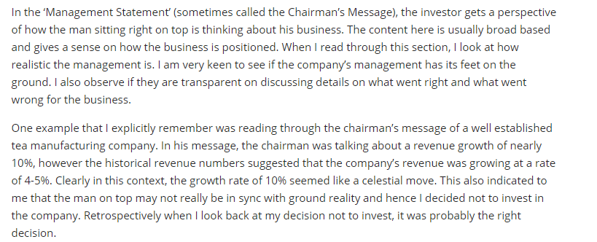

Below is example for CEO comments

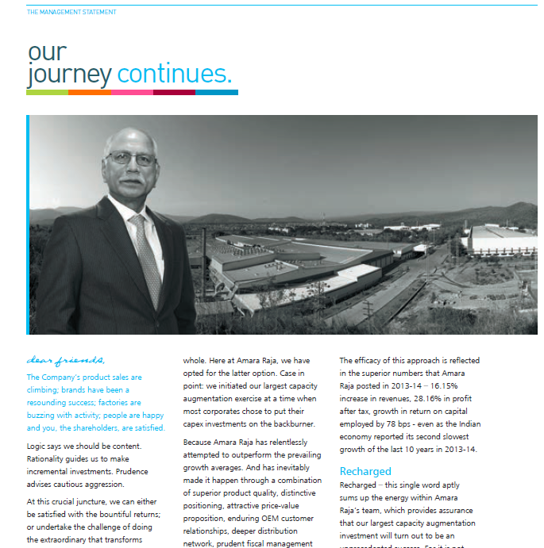

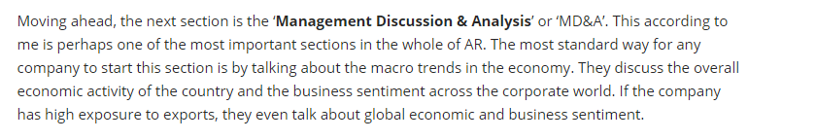

 I would be particularly interested in the human resources report to understand if the company has any labor issues. If there are serious signs of labor issues then it could potentially lead to the factory being shut down, which is not good for the company’s shareholders.

**Financial Statements:-**



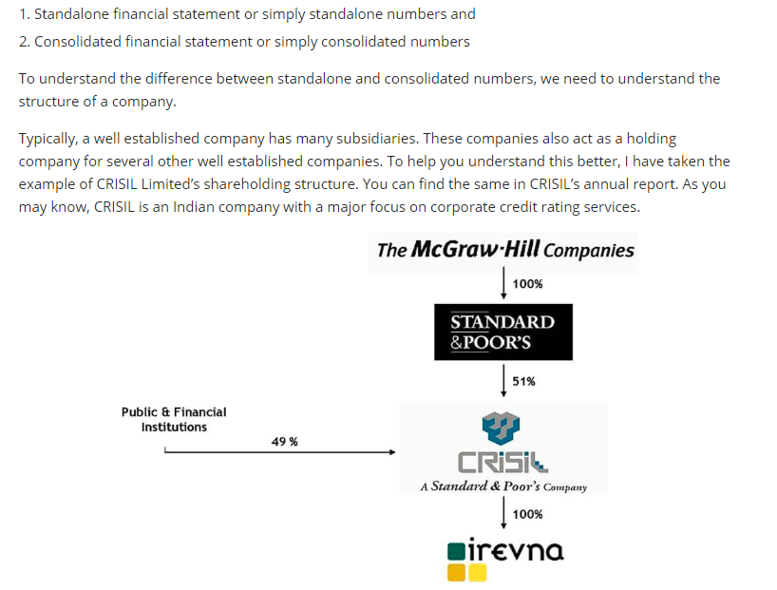

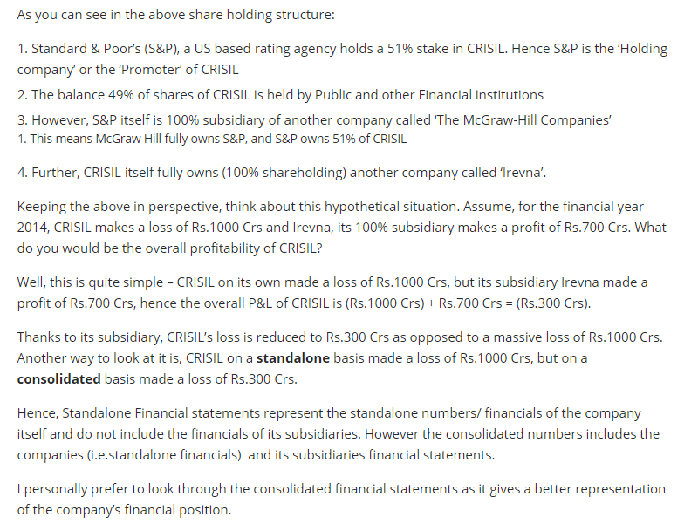

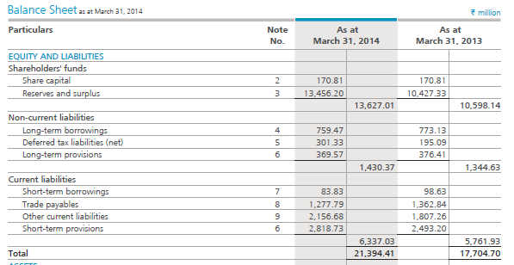

Each particular in the financial statement is referred to as the line item. For example the first line item in the Balance Sheet (under Equity and Liability) is the share capital. If you notice, there is a note number associated with share capital. These are called the ‘Schedules’ related to the financial statement.

As an investor I obviously would be interested to know how ARBL arrived at Rs.17.081 Crs as their share capital. To figure this out, one needs to look into the associated schedule (note number 2).

